Super Excited To Own The Upcoming Iphone SE 2/Iphone 9

A Personal Account

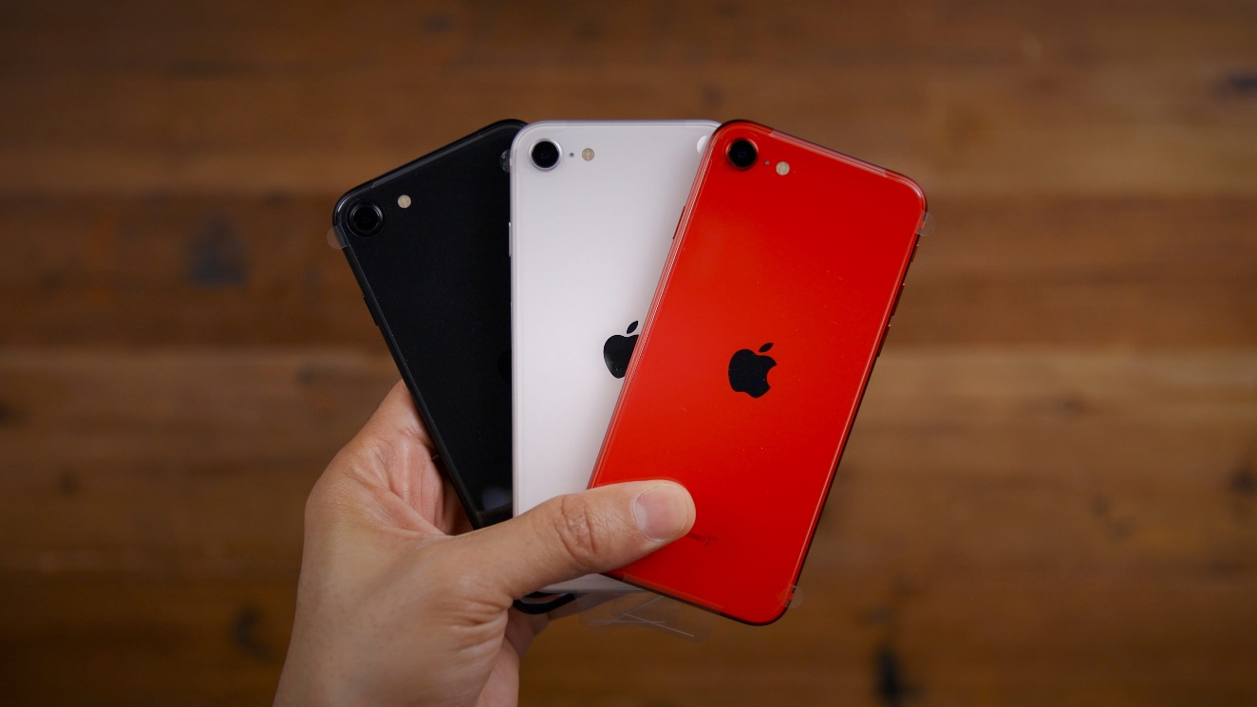

Iphones, of late, are following the cues from bigger sized android smartphones from its competitors and the latest one, Iphone 11, features a 6.1-inch screen. Another model launched, Iphone 11 pro max offers a 6.5-inch mammoth display. It’s needless to point out here that Iphones, irrespective of the specs, were well received all the time. This is attributed to the reputation the apple brand accumulated over the years with its unmatched performance, year after year. But, I’m particularly waiting to see the launch of the next Iphone which is believed to be smaller in size. This writing details my experience of using Iphone 5 and why I plan to buy the so-called Iphone SE 2/9.

**My Iphone 5**

I used an Iphone 5 model, for more than 4 years from 2014. The brand-new phone, gifted by my sister was a thing of beauty which brought a smile on my face and satisfaction in my mind, every time I unlocked it. It worked like magic by performing seamlessly. It was my college days and my seniors and juniors in hostel came to my room to see the high-priced phone, but they left the room realising the premium price was justified by the performance. Whether to take a snap, listen to a song or a game of clash of clan, it was a joy to use the device. During that period, I have seen new phones with much superior specs being launched and I have used a few premium phones of the time, owned by my friends. Even though the price tag for those phones were reasonable, none were as impressive to outperform an Iphone 5.

**Iphones and Not Iphones**

When it comes to an Iphone, specification numbers really don’t matter. Why so? Let me tell you, an Iphone 5 model(it’s the only Iphone version to I’m familiar) with 1 GB ram can still stand in par with the latest Redmi note 9, which features a 4 GB ram, in terms of performing tasks(I have used Redmi note models).The snaps captured by single lens, 8 megapixels, i-5 camera are stunning enough to compare with those shot by today’s phones which features a camera panel of lenses. My Iphone 5 never gave me headaches by lag or stuck which was a common feature of then contemporary phones of premium category such as Samsung and Blackberry, to name a few. Nevertheless, as my Iphone battery degraded in the long run (over 4 years), started the occasional freezing of the phone, which prompted me to get rid of it, eventually. Also, Iphones are bit inconvenient in terms of connectivity and it necessitates use of iTunes to transfer media files from a personal computer. But the supreme user experience offered by the device just made it seem like these troubles don’t even exist.

**Little things add up**

My Iphone 5 user experience became a unique one, when the one of a kind software was coupled with the benchmark grade hardware. For me, the model got its edge from its exterior aspects which makes one forget the fact he is holding it. Simplicity and elegance, the lethal combination, is perfected in the device, from the way the unique silence button is positioned for effortless one-handed usage to the diamond machined edges on the aluminium panelled body. The device featured a modest 4-inch display which weighs just over 110 grams. This aspect I love the most as the compact, well-balanced device (literally the device is balanced, it can stand on a table along the length and breadth) which rests in pocket unexposed. The latest smartphones are quite over-weighted with most of the models are more than 180 grams with extra-large displays, including latest Iphone models. I feel it’s not fair to make a thing as important as a mobile phone heavy, which people carry all the time. Then, ease of use is out of picture as it takes quite an effort to use the big phones one handed. This is why I badly want to go back to the Iphone 5 kind phones.

**What to expect on SE 2**

Well, here there is hope for all wishing for a phone that is effortless to use and uncompromising in performance. Lately, I often wished to see an Iphone 5 with the latest processor which is somewhat affordable. The announcement of a budget Iphone was a happy news for me and when I learned Apple plans to cut short the phone size (so be weight), it was a bulls-eye for me. The to be launch phone is expected to have a display under 5-inch, with a single rear camera and will host the latest A-13 bionic chip. The price is speculated under 30,000 INR. For the past couple of years, I was in desperate wait to buy my new Iphone and now I feel happy that I waited. Updates from tech world indicate that the budget Iphone launch date is 15th April. Also, my experience using an Iphone suggests that the phone is extremely durable which if properly used can last 3-4 years, delivering optimum performance. Considering this, the ‘affordable’ high price of an Iphone is justifiable, as most other brand smartphones need occasional upgrading. The exciting thing for me is that I can just start from where I stopped with my Iphone 5 with a model which is very much like it. I have experienced ‘a thing of beauty is a joy forever’ even though thing of beauty is not that cheap.